Ex.no:5b | DATA VISUALIZATION USING MATPLOTLIB –  CHESS DATA

Aim:
To visualize the features and distributions of the Chess Games Dataset using scatter plots, box plots, heatmaps, count plots, histograms, pie charts, bar charts, pair plots, bubble charts, and violin plots using Matplotlib and Seaborn.
Algorithm:
ALGORITHM 1: SCATTER PLOT
- Load the Chess Games dataset.
- Select white_rating as the X-axis variable.
- Select black_rating as the Y-axis variable.
- Create a scatter plot.
- Add a suitable title.
- Add X-axis and Y-axis labels.
- Display the graph.
ALGORITHM 2: BOX PLOT
- Select the turns column.
- Create a box plot.
- Add a suitable title.
- Add an axis label.
- Display the plot.
ALGORITHM 3: CORRELATION HEATMAP
- Select turns, white_rating, black_rating, and opening_ply.
- Calculate the correlation matrix using corr().
- Create a heatmap using the correlation matrix.
- Display the correlation values.
- Add a suitable title.
- Display the graph.
ALGORITHM 4: COUNT PLOT
- Select the winner column.
- Count the different winner categories.
- Create a count plot.
- Add a suitable title.
- Add X-axis and Y-axis labels.
- Display the graph.

ALGORITHM 5: HISTOGRAM
- Select the turns column.
- Divide the turn values into suitable bins.
- Create a histogram.
- Add a suitable title.
- Add X-axis and Y-axis labels.
- Display the histogram.
ALGORITHM 6: PIE CHART
- Count the values in the winner column.
- Store the counts for White, Black, and Draw.
- Create a pie chart.
- Add percentage labels.
- Add a suitable title.
- Display the chart.
ALGORITHM 7: BAR CHART
- Group the dataset based on the winner attribute.
- Select the turns attribute.
- Calculate the average number of turns for each winner category.
- Sort the grouped results in descending order.
- Create a bar chart.
- Add a suitable title.
- Add X-axis and Y-axis labels.
- Display the graph.
ALGORITHM 8: HISTOGRAM WITH KDE
- Select the turns column.
- Divide the values into suitable bins.
- Create a histogram.
- Add a KDE curve to represent the density.
- Add a suitable title.
- Add X-axis and Y-axis labels.
- Display the graph.
ALGORITHM 9: PAIR PLOT
- Select turns, white_rating, black_rating, and opening_ply.
- Generate pairwise plots using pairplot().
- Display the relationships between the selected attributes.
- Display the individual distributions of the attributes.
ALGORITHM 10: BUBBLE CHART
- Select white_rating as the X-axis variable.
- Select black_rating as the Y-axis variable.
- Use turns to determine the bubble size.
- Use the winner category to represent the game outcome using different colors.
- Add a suitable title.
- Add X-axis and Y-axis labels.
- Display the chart.
ALGORITHM 11: VIOLIN PLOT
- Select winner as the categorical variable.
- Select turns as the numerical variable.
- Create a violin plot.
- Add a suitable title.
- Add X-axis and Y-axis labels.
- Display the graph.
ALGORITHM 12: CATEGORY-WISE BOX PLOT
- Select winner as the categorical variable.
- Select turns as the numerical variable.
- Create a category-wise box plot.
- Add a suitable title.
- Add X-axis and Y-axis labels.
- Display the graph.

Output:

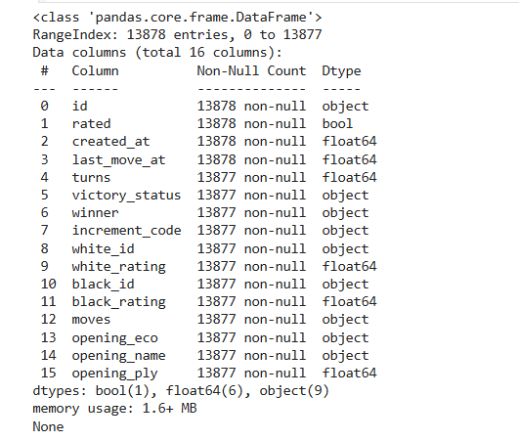
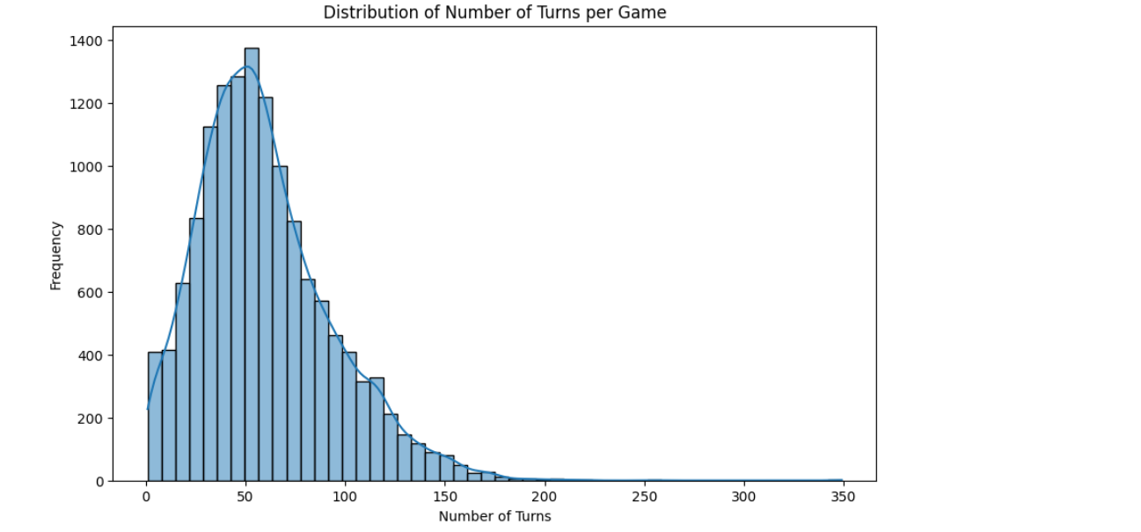
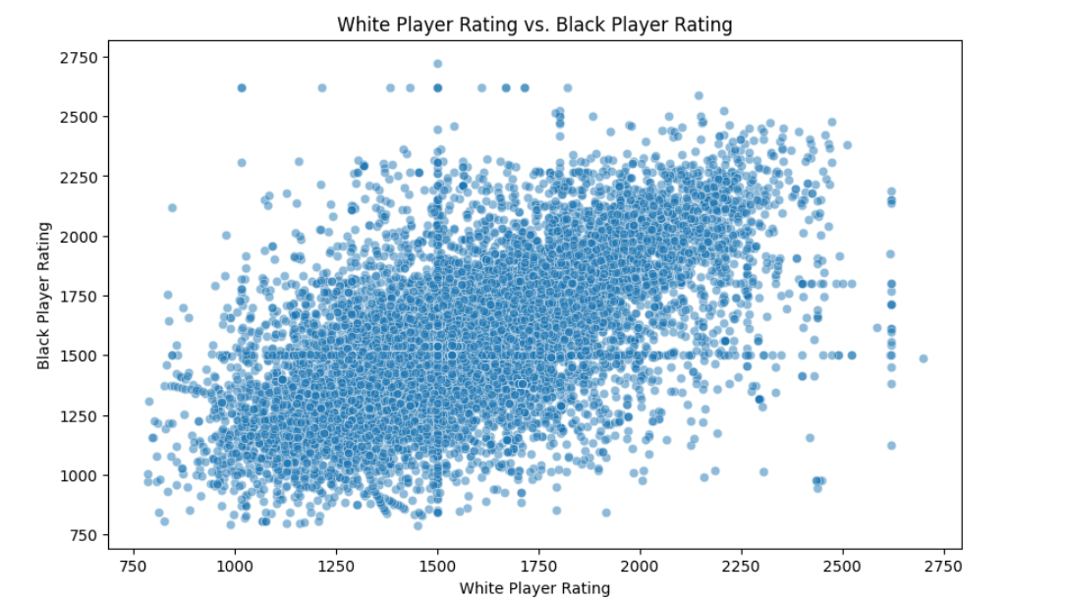
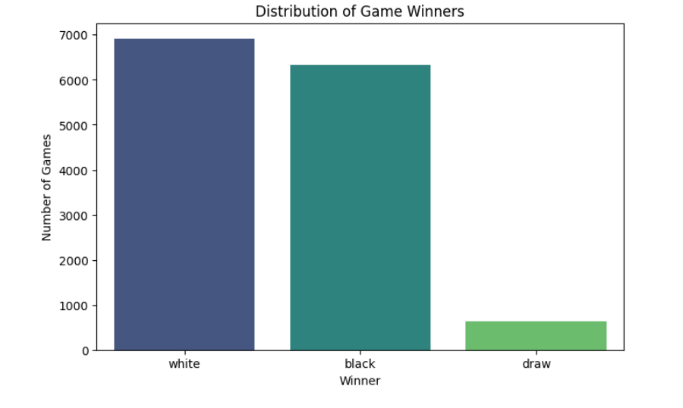
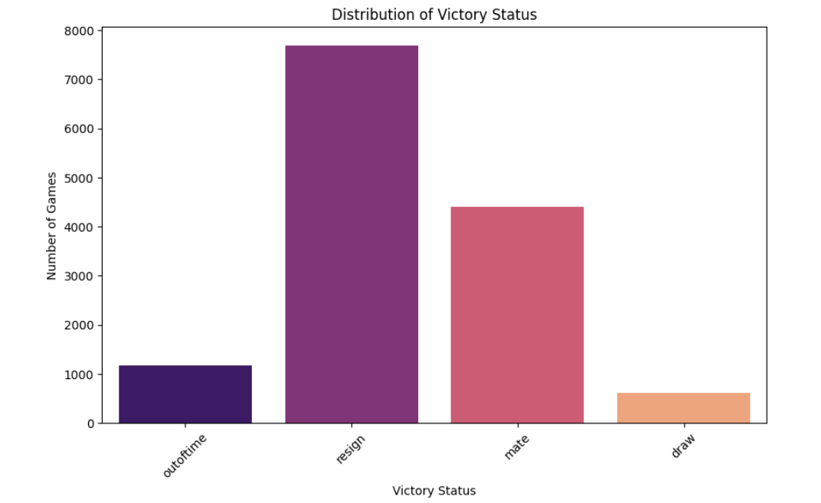
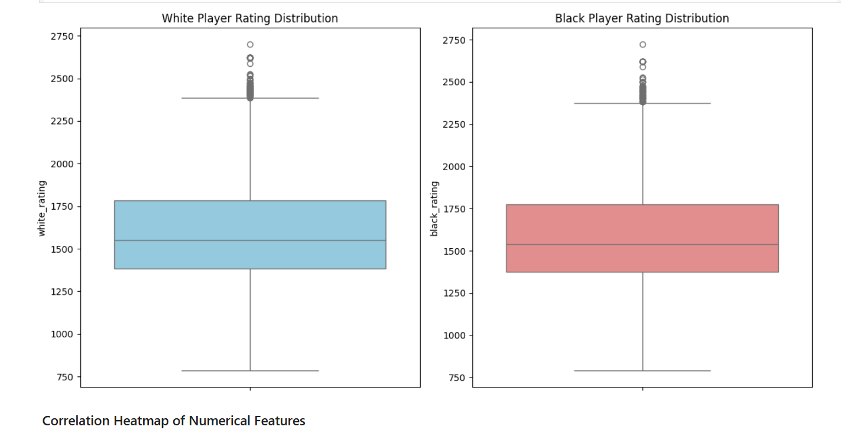
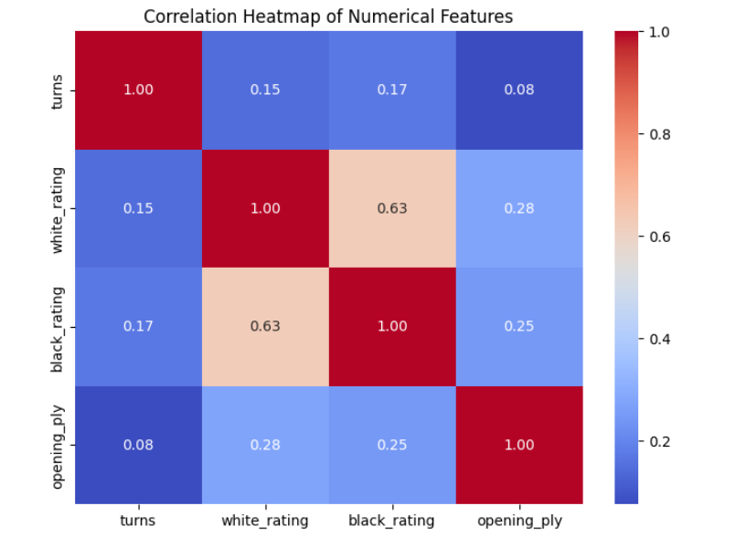
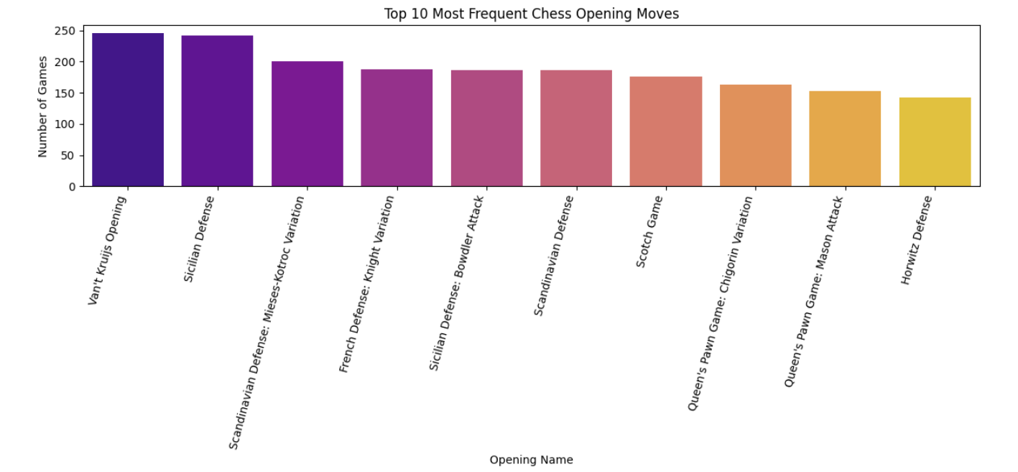

Result:

